**Linux Basics**

ls-> list the name of the files in the current directory

ls -la -> provides the complete details regarding the files

-rw-r—r—1 root root 46 may 22 10:51 abc.txt

Here -indicates file and d indicates directory

**Permissions**

Owner

Group

Other users

All

r->read ,w->write, x-> execute

**Chmod**

To change the security of the certain file

chmod [options][mode][filename]

Eg:

chmod o+x abc.txt

here, o indicates other users and + indicates adding permission , x indicates the execution persmission and abc is the file name

0-> ---

1-> --x

2-> -w-

3-> -wx

4-> r—

5-> r-x

6-> rw-

7-> rwx

**Ownership**

To change the ownership of the file and special access

Chown [options] [newowner] filename

Here,

Options -> -c it notifies regarding the change

-v it notifies with more details

-r it changes the ownership for all the files in the directory

-f it overrides if there any errors during this process

Chown :newowner filename -> changes special access

Chown newowner: filename -> changes ownership

**To save the file in terminal**

a,i -> insert

:wq -> save

:q! -> exit without saving

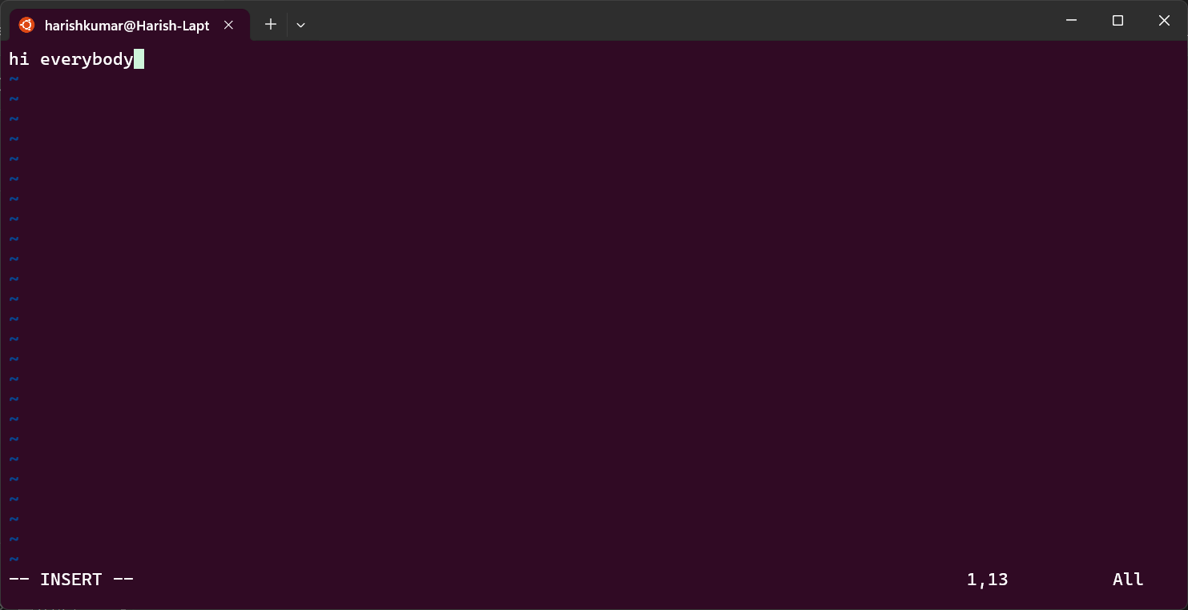

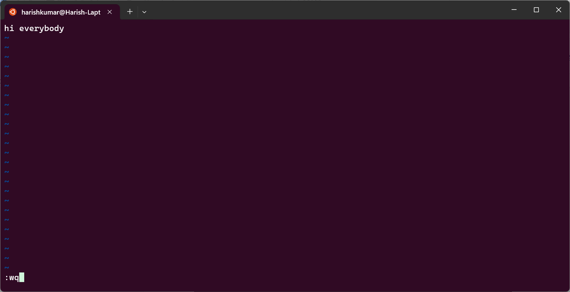

Linux shell -> used to communicate the program

**Basic commands**

mv-> rename the file

cp-> to copy the file cp -r -> to copy the complete directory with all files

rmdir-> delete the directory

mkdir-> create the directory

change password->passwd

disk usage-> du -h

users ->shows the user names

ls -l->shows only non hidden files with details

ls -la->shows with hidden files with details

ls -a-> shows only name of the files

cd ~ ->back to the home directory

cd - -> shows the previous path of the file which is used

cat -> shows the file contents

wc filename ->show the count of words in the file as line count word count charactercount+(1 for each line)

ln -s filename linkname ->soft link

ln filename linkname ->hardlink

ping ip address-> to usage under current ip address

ftp ipaddress-> transfer files

telnet websitename ->communication

ENVIRONMENT VARIABLES

$test= “unix”

$echo $test

$path=/bin:/user/bin

GREP

Grep [options] “pattern” [filename]

Top-> like task manager shows all workings

Kill -9 (PID number) eg:kill -9 3784 (it kills that process)

NANO

Nano file name

Ctrl+o

Enter

Ctrl+x

su - -> switchuser root(main user)

whoami -> to know the current user

ifconfig,

if a -> ip address

# -> root account

$ -> normalaccount

clear ->ctrl+l

hostname -> name of current linux system

stop -> ctr+c

man ls -> shows the command uses(man)______ 'q' to exit

passwd,

passwd (username)-> change password

ls -> shows the files in that directory

cd ->change directory(cd /usr/bin)

pwd ->print working directory

cd .. ->move to back folder from current

.filename ->these files are hidden files

ls -R ->shows the file name in downward direction

ls -l -> shows with extra details

ls -l my* -> *is used for filtering the file name with starting letters my

ld -l myscrit?t ->wildcard character(?)

touch filename ->create file

cp soucefile destfile ->copying file

ln -s filename linkfilename -> symbolic link creation

ln filename linkfilename -> hardlink creation

mv oldname newname (ifneeded)path->rename file

rm filename ->remove file

rm -i filename ->remove file (yes or no)

rm (pathtodirectory)* -> remove all nopnhidden files

mkdir file name ->make directory

rmdir filename -> remove directory